
Highways, Traffic and Parking
Schemes
London Borough of Havering
Town Hall,
Main Road
Romford RM1 3BB

Email: schemes@havering.gov.uk

Date: 07th March 2025

Ref: C42650

Dear Residents

Whitchurch Road, Romford
- Proposed zebra crossing

We want to hear your views on Havering Council’s proposal to introduce a zebra crossing in Whitchurch Road, Romford.

The proposed crossing should enhance and ensure safer crossing facilities for residents including vulnerable road users such as those with mobility issues wishing to cross Whitchurch Road.

The plan showing the location of the proposed crossing can be found below.

Your comments to the proposal should be sent in writing via email to schemes@havering.gov.uk no later than Friday 28 March 2025.

All the responses received will be carefully analysed and can influence the final scheme design. We will make changes based upon suggestions and comments where feasible; and if changes are not possible, we will explain why. Elements of the scheme that are not well supported by residents may be reconsidered if possible.

The quickest way to advise us of if you would be supportive of proposed zebra crossing would be to complete the questionnaire below or via e-mail.

For further information, please contact via the e-mail address shown at the top of this letter.

https://consultation.havering.gov.uk/highways/whitchurch-road


Yours faithfully,

The Schemes Team

Plans:
Sheet 1 of 1
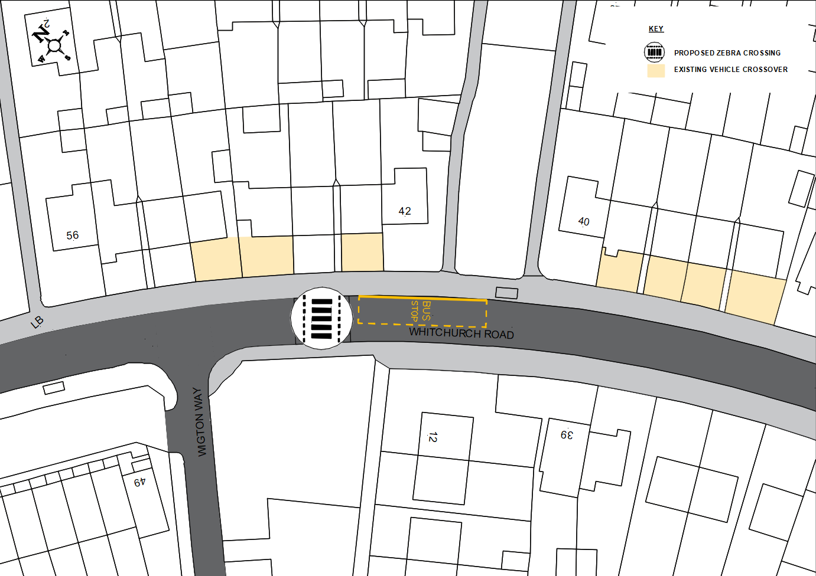

- Are you supportive of the overall proposal?
□ Yes □ No □ Not sure

- Are you supportive of the proposed zebra crossing outside No 46 Whitchurch
Road?
□ Yes □ No □ Not sure

- Please provide any other comments you have in relation to the proposal set
out in this letter

