
Highways, Traffic and Parking
Schemes
London Borough of Havering
Town Hall,
Main Road
Romford RM1 3BB

Email: schemes@havering.gov.uk

Date: 21st February 2025

Ref: C42670

Dear Residents

Paine’s Brook Park
- Proposed shared footpath improvements

We want to hear your views on Havering Council’s proposal to widen the existing shared footpath in Paine’s Brook Park, Romford.

The widened footpath will enhance the existing pathway, creating more space for both pedestrians and cyclists. This improvement aims to provide a safer and more comfortable environment for everyone using the footpath, reducing congestion and promoting a healthier, more active lifestyle. By expanding the footpath, we can accommodate the growing number of people who choose to walk or cycle, making our community more accessible and enjoyable for all.

The plan showing the location of the proposed crossings can be found below.

Your comments to the proposals should be sent in writing via email to schemes@havering.gov.uk no later than Friday 14 March 2025.

All the responses received will be carefully analysed and can influence the final scheme design. We will make changes based upon suggestions and comments where feasible; and if changes are not possible, we will explain why. Elements of the scheme that are not well supported by residents may be reconsidered if possible.

The quickest way to advise us of if you would be supportive of proposed works would be to complete the questionnaire below or via e-mail.

For further information, please contact via the e-mail address shown at the top of this letter.
https://consultation.havering.gov.uk/highways/gooshays-drive


Yours faithfully,

The Schemes Team
Plans:
Sheet 1 of 1
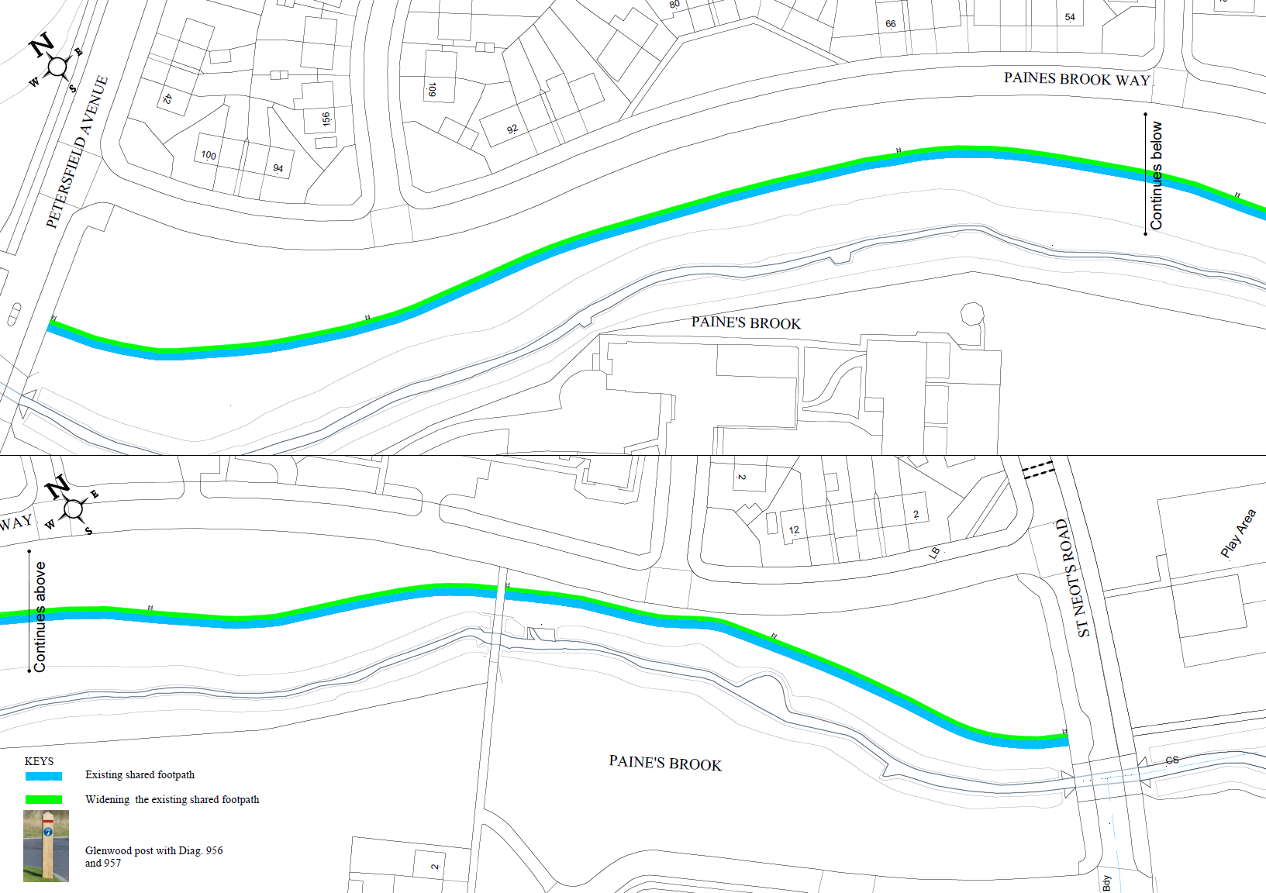

- Are you supportive of the overall proposal?
□ Yes □ No □ Not sure

- Are you in favour of the proposed footpath widening on Paine’s Brook Park?
□ Yes □ No □ Not sure

- Please provide any other comments you have in relation to the proposal set
out in this letter

