
Highways, Traffic and Parking
Schemes
London Borough of Havering
Town Hall,
Main Road
Romford RM1 3BB

Email: schemes@havering.gov.uk

Date: 06th December 2024

Ref: C42290

Dear Residents

Firbank Road, Romford
- Proposed raised zebra crossings

We want to hear your views on Havering Council’s proposals to introduce zebra crossing in Firbank Road, Romford.

The crossings will help to provide and improve safer crossing facilities for residents and students attending Oasis Academy Pinewood.

The plans showing the location of the proposed crossings can be found below.

Your comments to the proposals should be sent in writing via email to schemes@havering.gov.uk no later than Tuesday 31 December 2024.

All the responses received will be carefully analysed and will influence the final scheme design. We will make changes based upon suggestions and comments where feasible; and if changes are not possible, we will explain why. Elements of the scheme that are not well supported by residents may be reconsidered if possible.

The quickest way to advise us of if you would be supportive of proposed zebra crossings would be to complete the questionnaire below or via e-mail.

For further information, please contact via the e-mail address shown at the top of this letter.


https://consultation.havering.gov.uk/highways/firbank-road

Yours faithfully,

The Schemes Team

Plans:
Sheet 1 of 1
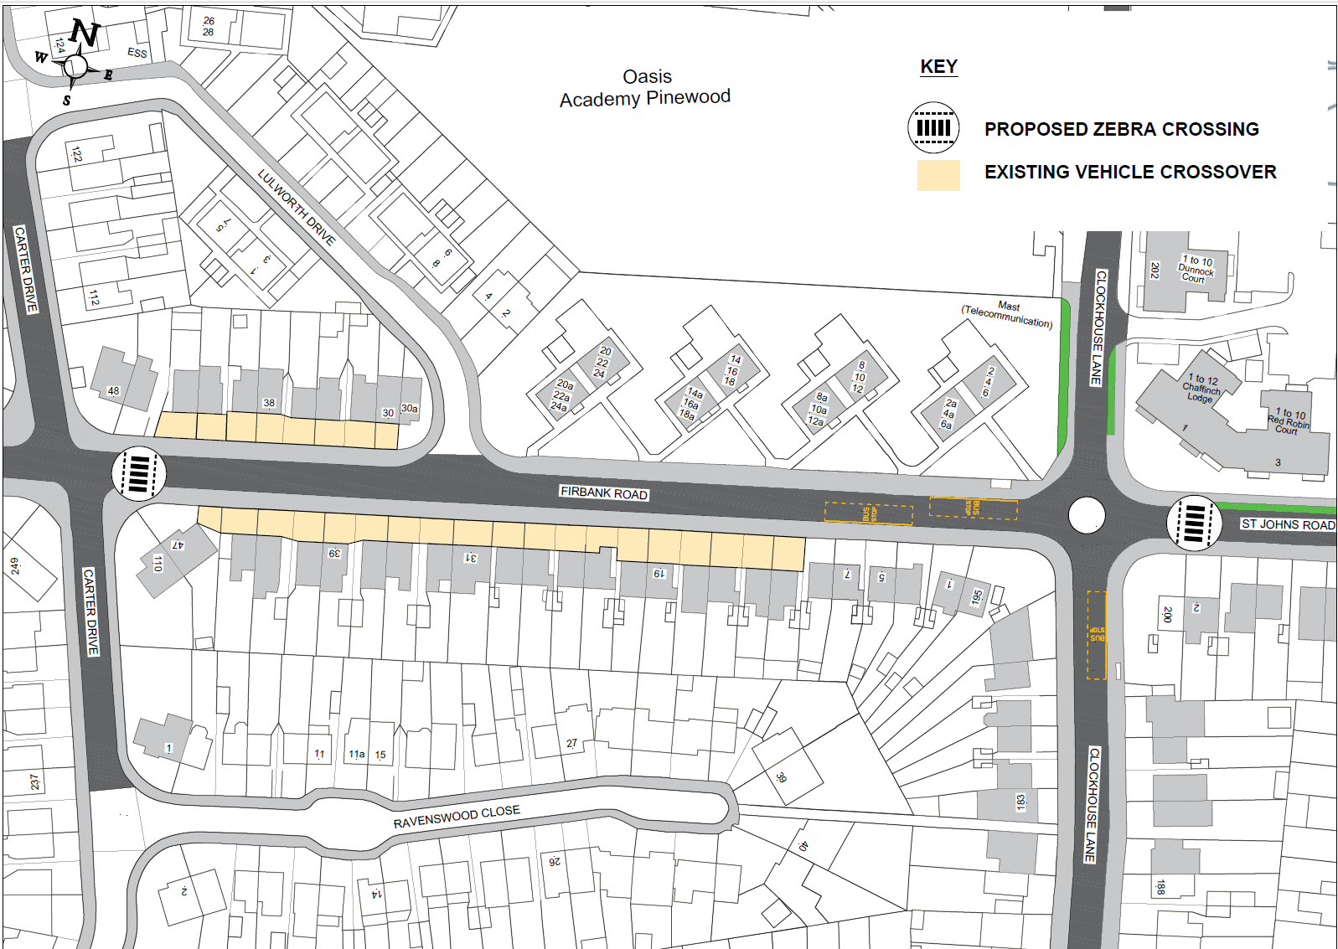

- How supportive are you of the overall proposals?
□ Positive □ Neutral □ Negative

- How supportive are you of the proposed zebra crossing outside No 2 St Johns
Road?
□ Positive □ Neutral □ Negative

- How supportive are you of the proposed raised zebra crossing outside No 48
Firbank road?
□ Positive □ Neutral □ Negative

- Please provide any other comments you have in relation to the proposals set
out in this letter

