
Highways, Traffic and Parking
Schemes
London Borough of Havering
Town Hall,
Main Road
Romford RM1 3BB

Email: schemes@havering.gov.uk

Date: 31th October 2023

Ref: C40350

Dear Residents

Branfil Primary School –
Proposed school travel measures

We are writing to inform you that we are carrying out a further consultation on proposed zebra crossings in Gaynes Park Road and the crossing in Cedar Avenue until Tuesday 21 November 2023. This is because the previous consultation included a question in error for which we apologise, this question may have influenced responses to other elements of the proposals.

The two elements being consulted on going forward are;
- Zebra Crossing on Gaynes Park Road.
- Informal crossing on Cedar Avenue (this is an optional element of works).
We would like to make clear that these proposals are externally funded following successful bids, as such all funding is ring-fenced and cannot be used elsewhere in the Council.

Please note the existing School Street scheme will remain in place and is not included as part of this consultation.

If you have not yet given your view on the proposals, or would like to make a new comment, you can do so by completing an online questionnaire, using the link or scanning the QR code below. The drawings of the proposals are also available via the link below. A paper copy of the questionnaire is also enclosed.

All responses received will be carefully reviewed and will help influence the final scheme design. We will make changes based upon suggestions and comments where feasible. If changes are not possible, we will explain why. Elements of the scheme that are not well supported by residents, may be reconsidered if possible.

For further information, please contact the Schemes team via the e-mail address shown at the top of this letter.
https://consultation.havering.gov.uk/parking/branfil-primary-school


Yours faithfully,
The Schemes Team
Plans:
Sheet 1 of 1
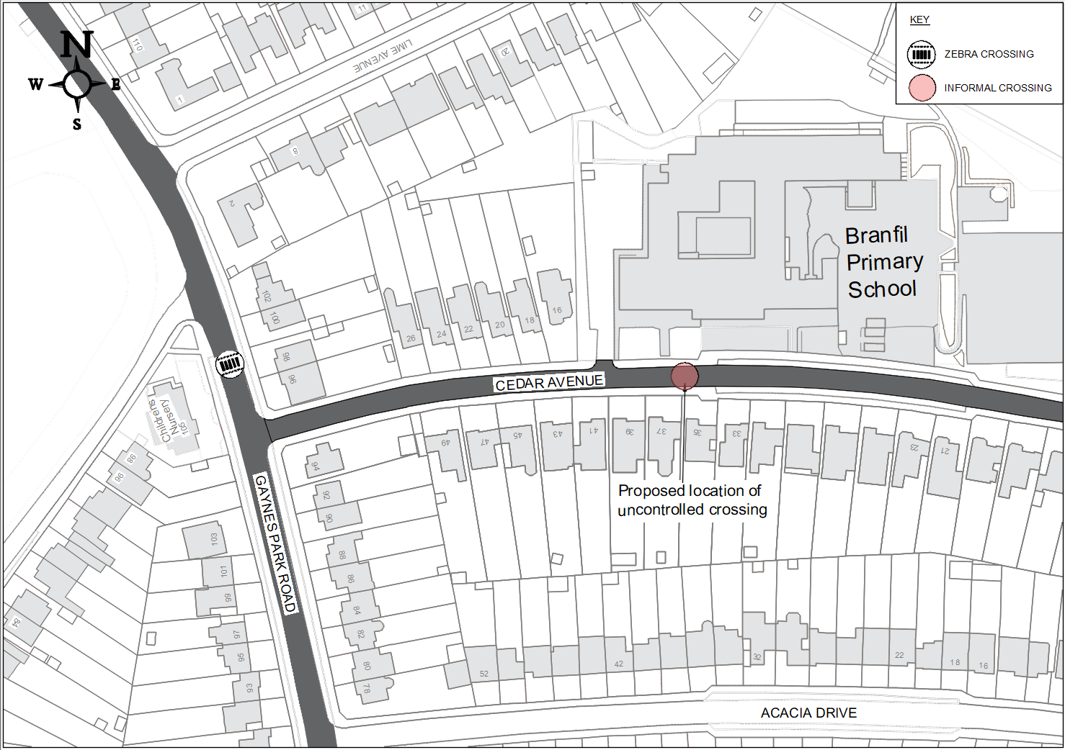

Example of a Zebra (controlled) crossing.
Zebra crossings are controlled crossings where pedestrians have a legal priority over vehicles without the use of traffic signals. This can make them safer than they first appear as the pedestrian must ensure that the traffic has seen them and stopped before crossing the road.

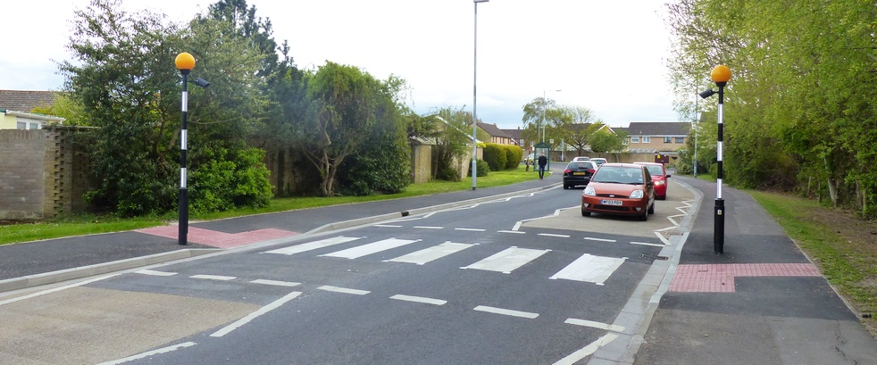

Example of uncontrolled or informal crossing.
Drivers are not required to stop at an uncontrolled crossing point. The pedestrian must wait at the kerb until there is a suitable gap in traffic to allow them to cross and should only then cross with due care and attention.

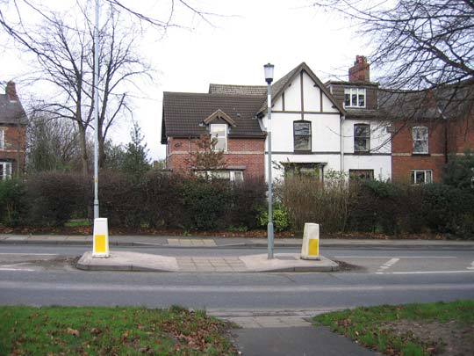

Ref: C40350

What is your name?

What is your email address?

What is your address and post code?

- How supportive are you of the overall proposals?
□ Positive
□ Neutral
□ Negative

- How supportive are you of the proposed zebra crossing outside Bright Horizons
Gaynes Park Day Nursery and Pre-School?
□ Positive
□ Neutral
□ Negative

- How supportive are you of the proposed informal crossing outside Branfil Primary School?
□ Positive
□ Neutral
□ Negative

- Please provide any other comments you have in relation to the proposals set
out in this consultation.

