Equality & Health Impact Assessment
(EqHIA)

Document control

Title of activity: | Home to School Transport Policy and protocol
Lead officer: | Jodie Gutteridge | Corporate Policy & Performance Lead
Approved by: | Trevor Cook | AD Education
Scheduled date for next review: | One year after when the policy is reviewed.

Did you seek advice from the Corporate Policy & Diversity team?  Please note that the Corporate Policy & Diversity and Public Health teams require at least 5 working days to provide advice on EqHIAs. | Yes
Did you seek advice from the Public Health team? | Yes
Does the EqHIA contain any confidential or exempt information that would prevent you publishing it on the Council’s website ?  See Publishing Checklist. | No
Please note that EqHIAs are public documents and unless they contain confidential or sensitive commercial information must be made available on the Council’s EqHIA webpage.

Please submit the completed form via e-mail to EqHIA@havering.gov.uk thank you.

Equality & Health Impact Assessment Checklist

Please complete the following checklist to determine whether or not you will need to complete an EqHIA and ensure you keep this section for your audit trail. If you have any questions, please contact EqHIA@havering.gov.uk for advice from either the Corporate Diversity or Public Health teams. Please refer to the Guidance in Appendix 1 on how to complete this form.

About your activity
1 | Title of activity | Home to School Transport Policy and Protocol
2 | Type of activity | Policy
3 | Scope of activity | Complaints and compliments policy, which will include guidance for staff and complainants on Members Enquiries, Social care complaints, housing complaints and Access to Information requests
4a | Are you changing, introducing a new, or removing a service, policy, strategy or function? | Yes | If the answer to either of these questions is ‘YES’,  please continue to question 5. |  | If the answer to all of the questions (4a, 4b & 4c) is ‘NO’, please go to question 6.
4b | Does this activity have the potential to impact (either positively or negatively) upon people from different backgrounds. | Yes
4c | Does the activity have the potential to impact (either positively or negatively) upon any factors which determine people’s health and wellbeing? | Yes | Please use the Screening tool before you answer this question. | If you answer ‘YES’,  please continue to question 5.
5 | If you answered YES: | Please complete the EqHIA in Section 2 of this document. Please see Appendix 1 for Guidance.
6 | If you answered NO: | N/A

Completed by: | Jodie Gutteridge
Date: | 11/09/2023

The EqHIA – How will the strategy, policy, plan, procedure and/or service impact on people?

Background/context:
This policy outlines the support and assistance available for children and young people travelling between home and school/college. Support and guidance may be provided by the council based on the different eligibility criteria, which is dependent on the age of the student.

Most children and young people will access school/college supported by their family /carer without additional assistance from the Council. Where assistance is given, it should be part of a plan that encourages children and young people to become more independent and resilient in their future lives, while encouraging sustainable forms of travel, including walking, cycling, scooting and the use of public transport.

The purpose of the home to school transport service is to enable students with special educational needs to benefit from free travel to and from school, if they live more than the distance specified by statute from their catchment school.

The child is entitled to free school meals (parents are in receipt of maximum working tax credits) and their nearest suitable school is:
- Beyond 2 miles (for children over the age of 8 and under 11)
- Between 2-6 miles (if aged 11-16)
- Between 2 and 15 (if the nearest school is preferred on the ground of religion or belief (aged 11-16))
*Expand box as required

Who will be affected by the activity?
Those Children, young people and their families, with special educational needs and who are eligible for home to school travel arrangements.
*Expand box as required

Protected Characteristic - Age: Consider the full range of age groups
Please tick (ü) the relevant box: |  | Overall impact:  The number of people that live in Havering has increased over the last decade from 237,232 in 2011 to 262,052 in 2021. This is a 10.5% increase compared to a 7.7% increase across London and a 6.6% increase across England.  The population of Havering is anticipated to grow by 15k (5.6%) from 266k in 2022 to 281k in 2032.  The number of children aged under 18 has seen an increase of 15.2% (from 50,827 to 58,550), greatly outpacing the 4.8% and 3.9% increases in London and England, respectively. Havering now has a higher proportion of children aged 0-17 (22.3%) than 80% of local authorities in England. This increase is slightly lower than the latest ONS projections (2018). The ONS predicts that the 0-17 population will grow to 61,350 by 2031.  Create your own tables, Table Tool – Explore education statistics – GOV.UK (explore-education-statistics.service.gov.uk)  *Expand box as required
Positive
Neutral | ü
Negative
Evidence:

*Expand box as required
Sources used:

Census 2021

Joint Strategic Needs Assessment 2022

*Expand box as required

Protected Characteristic - Disability: Consider the full range of disabilities; including physical, mental, sensory, progressive conditions and learning difficulties. Also consider neurodivergent conditions e.g. dyslexia and autism.
Please tick (ü) the relevant box: |  | Overall impact:  In Havering an estimated 38,449 residents reported having a disability in 2021. This is an age-standardised proportion (ASP) of 15.3%, which is slightly lower than London (15.6%) and lower than England (17.7%). In Havering, an ASP of 6.6% reported that their day-to-day activities were limited a lot and 8.7% reported their day-to-day activities were limited a little, due to a disability.  29,742 households in Havering had at least one person with a disability. Of these households, 6,181 had two or more members with a disability.  Children have special educational needs if they have a learning difficulty which calls for special educational provision to be made for them. An Education, Health and Care (EHC) plan details the education, health and social care support that is to be provided to a child or young person who has Special Educational Needs (SEN) or a disability. Havering has 8.9% primary school age children, 8.5% Secondary school children and 1.1% Special School children who are getting SEN Support.  By implementing this policy, it is anticipated that those children, young people and their families with special educational needs will have a positive outcome. This is because their needs will be looked at and the appropriate measures will be put into place to accommodate them.  *Expand box as required
Positive | ü
Neutral
Negative
Evidence:
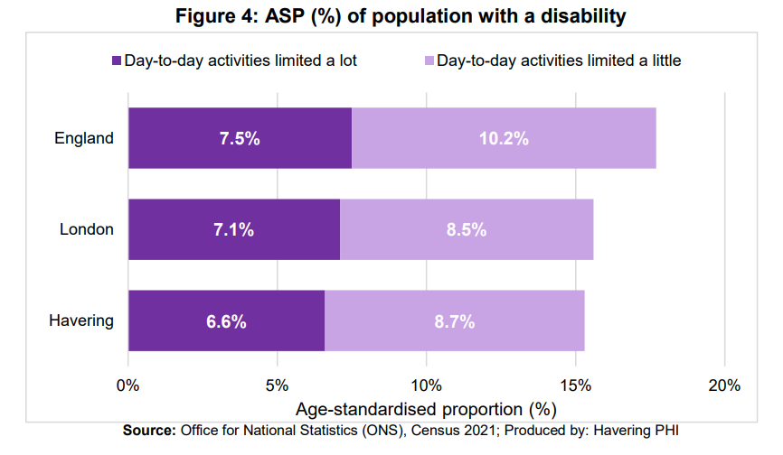

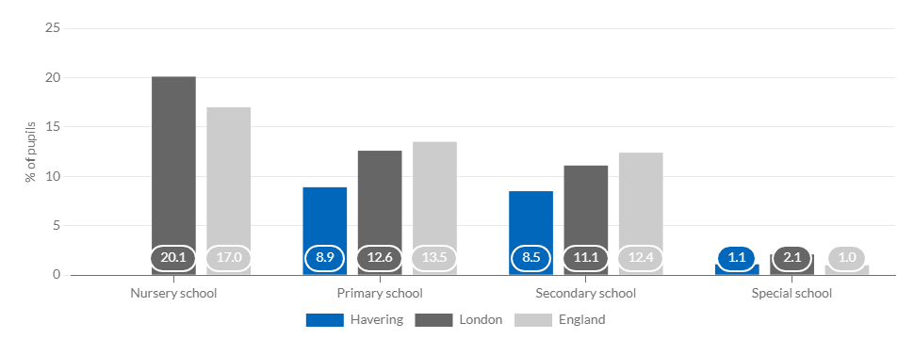
Source: DfE

*Expand box as required
Sources used:

Census 2021

https://www.haveringdata.net/wp-content/uploads/2023/02/Census-2021-Topic-Summary-Health-Disability-and-Unpaid-Care.pdf

https://www.haveringdata.net/children-and-young-people/#/view-report/07853ccb32274062987962b7d4e602b3/___iaFirstFeature/G3
*Expand box as required

Protected Characteristic – Sex / gender: Consider both men and women
Please tick (ü) the relevant box: |  | Overall impact:  Havering has 135,668 females (52%) and 126,384 males (48%) in the borough. 93.67% of Havering residents identify as the same gender as when they were born.  49% of pupils in Havering schools are female and 51% are male. This falls in line with the makeup of the borough.  The policy sets out the councils policy to offer free travel to their place of education for those children with special educational needs. It is not considered likely that there will be a disproportionate impact of these proposals on this protected characteristic group.  *Expand box as required
Positive
Neutral | ü
Negative
Evidence:

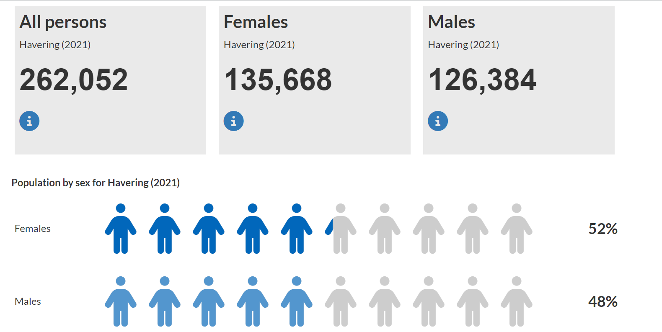

*Expand box as required
Sources used:

https://www.haveringdata.net/wp-content/uploads/2023/03/Topic-Summary-Sexual-orientation-and-gender-identity.pdf

www.Haveringdata.net
Census 2021

School Census
*Expand box as required

Protected Characteristic – Ethnicity / race / nationalities: Consider the impact on different minority ethnic groups and nationalities
Please tick (ü) the relevant box: |  | Overall impact:  Havering is becoming more diverse. In 2021 census, White British remains the most common ethnic group in Havering, with 66.5% (174,232) of the population, down from 83.3% (197,615) in 2011. The next most common ethnic group is Asian, accounting for 10.7% (28,150) of the population, up from 4.9% (11,545) in 2011.  In 2021, 87.8% (230,091) of usual Havering residents identified with at least one UK national identity (English, Welsh, Scottish, Northern Irish, British and Cornish). This is a decrease from 93.6% (222,066) in 2011. The figure for London in 2021 is 73.1% and England 90.3%. People who identified with at least one UK and one non-UK identity accounted for 1.8% (4,843) of the Havering population in 2021; this is an increase from 0.7% (1,680) in 2011. Those selecting a non-UK identity only accounted for 10.3% (27,118) of the Havering population in 2021, which is an increase from 5.7% (13,486) in 2011. Among those who described a non-UK national identity, the most common response was those describing “Romanian” as their national identity 2.0% (5,346) up from 0.2% (434) in 2011. The most common responses in 2011 were Irish 0.9% (2,037) and Lithuanian 0.5% (1,147).  Looking at the latest School Census, 74.36% of all students in Havering Schools spoke English as their first language. Romanian (4.10%), Urdu (2.04%) and Lithuanian (1.70%) were the next 3 common languages spoken in Havering schools.  90.1% of residents aged 3 and over describe their main language as English, next main languages Romanian 2.3% and Lithuanian 0.9%. 4.8% of households have no members where their main language is English.  Although there are a number of residents who identify as non-uk, it is not considered likely that introducing this policy will have a disproportionate impact on this protected characteristic group, as the policy sets out the councils policy to offer free travel to their place of education for those children with special educational needs. We do offer a translation service within Havering through ‘The language shop’ so the policy will be able to be interpreted shout it be required.  *Expand box as required
Positive
Neutral | ü
Negative
Evidence:

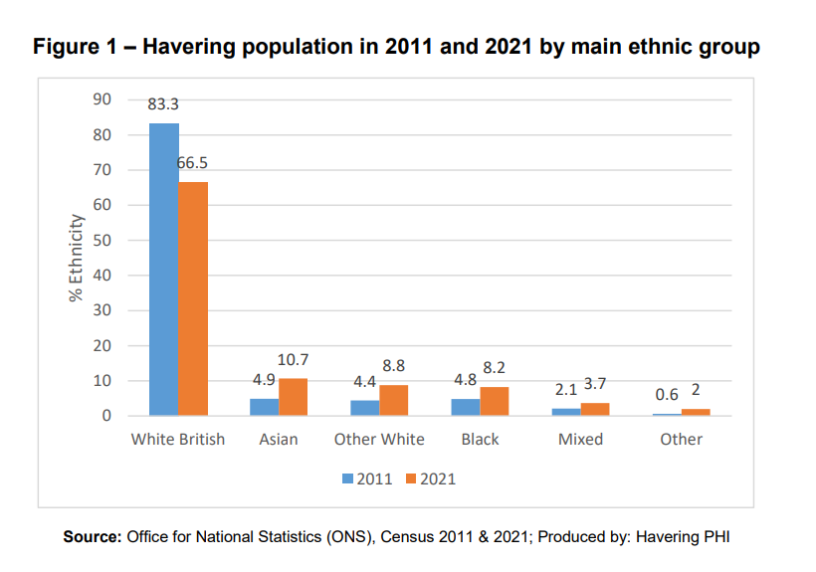

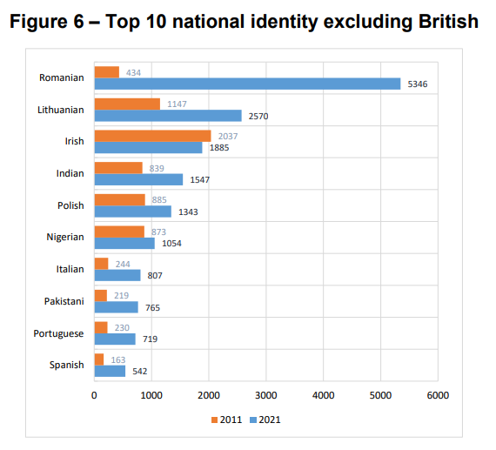

*Expand box as required
Sources used:

Census 2021
School Census
*Expand box as required

Protected Characteristic – Religion / faith: Consider people from different religions or beliefs, including those with no religion or belief
Please tick (ü) the relevant box: |  | Overall impact:  The religion question is voluntary in the Census, but 94.5% of usual residents answered the question in 2021. The most commonly reported religion in Havering is Christian, with 52.2% of the total population in 2021 describing themselves as Christian. This is a reduction from 65.6% in 2011. No religion was the second most common response, with 30.6% identifying in this category, up from 22.6% in 2011. Other religions accounted for 11.7% of the total Havering population, which is an increase from 5.1% in 2011.  The policy sets out the councils policy to offer free travel to their place of education for those children with special educational needs. It is not considered likely that there will be a disproportionate impact of these proposals on this protected characteristic group.  *Expand box as required
Positive
Neutral | ü
Negative
Evidence:
*Expand box as required
Sources used:

Census 2021
*Expand box as required

Protected Characteristic - Sexual orientation: Consider people who are heterosexual, lesbian, gay or bisexual
Please tick (ü) the relevant box: |  | Overall impact:  The Census question on sexual orientation was a voluntary question asked of those aged 16 years and over. The number of people responding was very high with 93% (195,099) of Havering residents answering the question. In total, 91.07% (191,007) of Havering residents identified as straight or heterosexual. In total, 1.95% (4,092) Havering residents identified as one of the LGB+ orientations (“Gay or Lesbian”, “Bisexual” or “Other sexual orientation”). In total, 6.98% (14,631) Havering residents did not answer the question.  The policy sets out the councils policy to offer free travel to their place of education for those children with special educational needs. It is not considered likely that there will be a disproportionate impact of these proposals on this protected characteristic group.  *Expand box as required
Positive
Neutral | ü
Negative
Evidence:

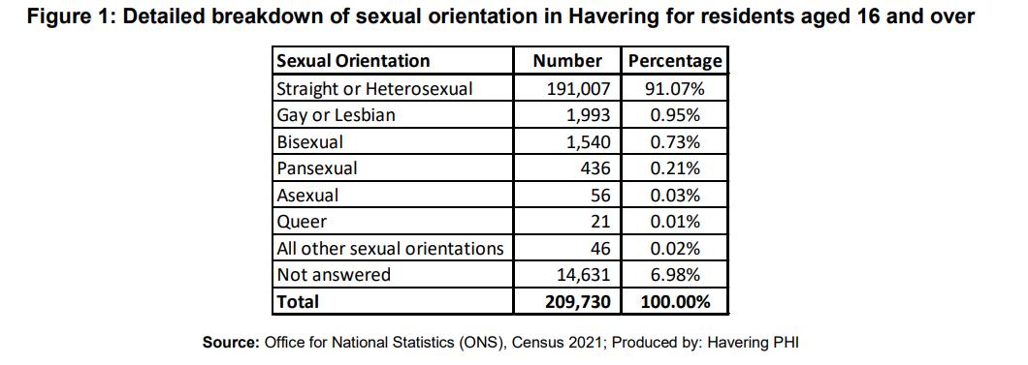

*Expand box as required
Sources used:

Census 2021

https://www.haveringdata.net/wp-content/uploads/2023/03/Topic-Summary-Sexual-orientation-and-gender-identity.pdf

*Expand box as required

Protected Characteristic - Gender reassignment: Consider people who are seeking, undergoing or have received gender reassignment surgery, as well as people whose gender identity is different from their gender at birth
Please tick (ü) the relevant box: |  | Overall impact:  The Census question on gender identity was also a voluntary question, asked of those aged 16 years and over. It was added to provide the first official data on the size of the transgender population in England and Wales. The question asked was “Is the gender you identify with the same as your sex registered at birth?” The number of people responding was very high with 94.2% (197,529) Havering residents answering the question. In total, 93.67% (196,462) Havering residents answered “Yes” and 0.51% (1,067) answered “No”. 5.82% (12,201) Havering residents did not answer the question.  The policy sets out the councils policy to offer free travel to their place of education for those children with special educational needs. It is not considered likely that there will be a disproportionate impact of these proposals on this protected characteristic group.  *Expand box as required
Positive
Neutral | ü
Negative
Evidence:

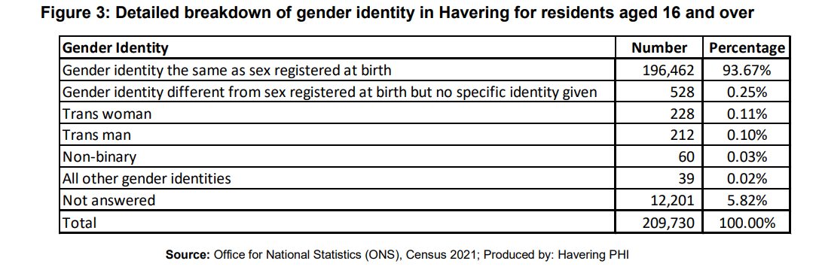

*Expand box as required
Sources used:

Census 2021

https://www.haveringdata.net/wp-content/uploads/2023/03/Topic-Summary-Sexual-orientation-and-gender-identity.pdf

*Expand box as required

Protected Characteristic – Marriage / civil partnership: Consider people in a marriage or civil partnership
Please tick (ü) the relevant box: |  | Overall impact:  The policy sets out the councils policy to offer free travel to their place of education for those children with special educational needs. It is not considered likely that there will be a disproportionate impact of these proposals on this protected characteristic group.  *Expand box as required
Positive
Neutral | ü
Negative
Evidence:
*Expand box as required
Sources used:
*Expand box as required

Protected Characteristic - Pregnancy, maternity and paternity: Consider those who are pregnant and those who are taking maternity or paternity leave
Please tick (ü) the relevant box: |  | Overall impact:  The policy sets out the councils policy to offer free travel to their place of education for those children with special educational needs. It is not considered likely that there will be a disproportionate impact of these proposals on this protected characteristic group.  *Expand box as required
Positive
Neutral | ü
Negative
Evidence:
*Expand box as required
Sources used:
Expand box as required

Socio-economic status: Consider those who are from low income or financially excluded backgrounds
Please tick (ü) the relevant box: |  | Overall impact:  59.5% of residents in Havering have a job, an increase from 58.9% in 2011.  3.6% of residents are unemployed, which is the fourth lowest rate in London but an improvement from the rate of 5.0% in 2011.  21.0% of residents are retired - the highest rate in London, which is in line with or high older person population.  Median gross weekly pay of people living in Havering (£705pw) is below the London average (£728pw) but significantly higher than the England average (£613pw). However, earnings of people who work in Havering (£614; who may or may not actually live in the borough) are very similar to the England average. This suggests that residents who work outside the borough e.g. commute into central London, attract a higher rate of pay than peers who work locally.  27,000 adults resident in the borough are income deprived overall, and there is significant variation across Havering.  19.72% (8371) of Havering pupils receive free school meals.  Being on a low income or financially excluded doesn’t necessarily mean those eligible children will be disadvantaged by this policy, in fact being eligible for a personal budget could assist the family by offering the means to purchase a family vehicle. However they may not have access to a computer or smart phone in order to complete all the necessary forms and the family would need to ensure that their family budget doesn’t compromise the ability to ensure the child is in attendance at school.  *Expand box as required
Positive
Neutral
Negative | ü
Evidence:

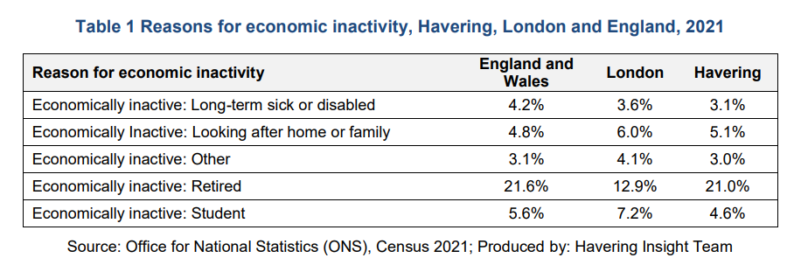

Phase | (All)
FSM | Pupils | %
-1 | 8371 | 19.72%
0 | 34081 | 80.28%
Grand Total | 42452 | 100.00%

*Expand box as required
Sources used:

Census 2021

School Census

https://www.haveringdata.net/wp-content/uploads/2023/02/Topic-Summary-Economic-Activity-and-Travel-to-work-Final-Version.pdf

Joint Strategic Needs Assessment

Health & Wellbeing Impact: Please use the Health and Wellbeing Impact Tool on the next page to help you answer this question.

Consider both short and long-term impacts of the activity on a person’s physical and mental health, particularly for disadvantaged, vulnerable or at-risk groups. Can health and wellbeing be positively promoted through this activity?
Please tick (ü) all the relevant boxes that apply: |  | Overall impact:  In Havering an estimated 219,777 residents had ‘good’ or ‘very good’ health in 2021. This is an age standardised proportion (ASP) of 83.0%, which is higher than London (81.9%) and England (81.7%). However, in Havering, an ASP of 48.2% residents had ‘very good’ health compared to 49% in London.  22.78% of those residents who completed the ONS annual population survey in 2020/21 self-reported their wellbeing as high anxiety.  The process to gain free travel for those children with special educational needs is long, this may impact upon some families with high anxiety to ensure the process is in place before the school starts.  The policy sets out the councils policy to offer free travel to their place of education for those children with special educational needs. It is not considered likely that there will be a disproportionate impact of these proposals on this protected characteristic group.  *Expand box as required  Do you consider that a more in-depth HIA is required as a result of this brief assessment? Please tick (ü) the relevant box  Yes o No ü
Positive
Neutral | ü
Negative
Evidence:

*Expand box as required
Sources used:
https://www.haveringdata.net/wp-content/uploads/2023/02/Census-2021-Topic-Summary-Health-Disability-and-Unpaid-Care.pdf

*Expand box as required

3. Health & Wellbeing Screening Tool
Will the activity / service / policy / procedure affect any of the following characteristics? Please tick/check the boxes below
The following are a range of considerations that might help you to complete the assessment.
Lifestyle YES NO | Personal circumstances YES NO | Access to services/facilities/amenities YES NO
Diet  Exercise and physical activity  Smoking  Exposure to passive smoking  Alcohol intake  Dependency on prescription drugs  Illicit drug and substance use  Risky Sexual behaviour  Other health-related behaviours, such as tooth-brushing, bathing, and wound care | Structure and cohesion of family unit  Parenting  Childhood development  Life skills  Personal safety  Employment status  Working conditions  Level of income, including benefits  Level of disposable income  Housing tenure  Housing conditions  Educational attainment  Skills levels including literacy and numeracy | to Employment opportunities  to Workplaces  to Housing  to Shops (to supply basic needs)  to Community facilities  to Public transport  to Education  to Training and skills development  to Healthcare  to Social services  to Childcare  to Respite care  to Leisure and recreation services and facilities
Social Factors YES NO | Economic Factors YES NO | Environmental Factors YES NO
Social contact  Social support  Neighbourliness  Participation in the community  Membership of community groups  Reputation of community/area  Participation in public affairs  Level of crime and disorder  Fear of crime and disorder  Level of antisocial behaviour  Fear of antisocial behaviour  Discrimination  Fear of discrimination  Public safety measures  Road safety measures | Creation of wealth  Distribution of wealth  Retention of wealth in local area/economy  Distribution of income  Business activity  Job creation  Availability of employment opportunities  Quality of employment opportunities  Availability of education opportunities  Quality of education opportunities  Availability of training and skills development opportunities  Quality of training and skills development opportunities  Technological development  Amount of traffic congestion | Air quality  Water quality  Soil quality/Level of contamination/Odour  Noise levels  Vibration  Hazards  Land use  Natural habitats  Biodiversity  Landscape, including green and open spaces  Townscape, including civic areas and public realm  Use/consumption of natural resources  Energy use: CO2/other greenhouse gas emissions  Solid waste management  Public transport infrastructure

Outcome of the Assessment

The EqHIA assessment is intended to be used as an improvement tool to make sure the activity maximises the positive impacts and eliminates or minimises the negative impacts. The possible outcomes of the assessment are listed below and what the next steps to take are:

Please tick (ü) what the overall outcome of your assessment was:
 | - The initial screening exercise showed a strong indication that there will be no impacts on people and need to carry out an EqHIA.  - The EqHIA identified no significant concerns OR the identified negative concerns have already been addressed |  | Proceed with implementation of your activity
ü | - The EqHIA identified some negative impact which still needs to be addressed |  | COMPLETE SECTION 5:  Complete action plan with measures to mitigate the and finalise the EqHIA
 | - The EqHIA identified some major concerns and showed that it is impossible to diminish negative impacts from the activity to an acceptable or even lawful level |  | Stop and remove the activity or revise the activity thoroughly.  Complete an EqHIA on the revised proposal.

Action Plan

The real value of completing an EqHIA comes from identifying the actions that can be taken to eliminate/minimise negative impacts and enhance/optimise positive impacts. In this section you should list the specific actions that set out how you will mitigate or reduce any negative equality and/or health & wellbeing impacts, identified in this assessment. Please ensure that your action plan is: more than just a list of proposals and good intentions; if required, will amend the scope and direction of the change; sets ambitious yet achievable outcomes and timescales; and is clear about resource implications.

Protected characteristic / health & wellbeing impact | Identified  Negative or Positive impact | Recommended actions to mitigate Negative impact* or further promote Positive impact | Outcomes and monitoring** | Timescale | Lead officer
Disbaility | Positive | Individual needs will be looked at and the appropriate measures will be put into place to accommodate them.
Socio-Economic | Negative | Potential to not have access to internet, computer or phone so we should look to accept applications through other means other than online I.e. provide paper copies as and when required | Applications can be accepted through any means

Review

In this section you should identify how frequently the EqHIA will be reviewed; the date for next review; and who will be reviewing it.

Review: This EqHIA will be reviewed following the closure of the public consultation and before the final policy is due to be approved.

Scheduled date of review: December 2023

Lead Officer conducting the review: Jodie Gutteridge

*Expand box as required

Please submit the completed form via e-mail to EqHIA@havering.gov.uk thank you.

